Evaluation Only. Created with Aspose.Words. Copyright 2003-2022 Aspose Pty Ltd.
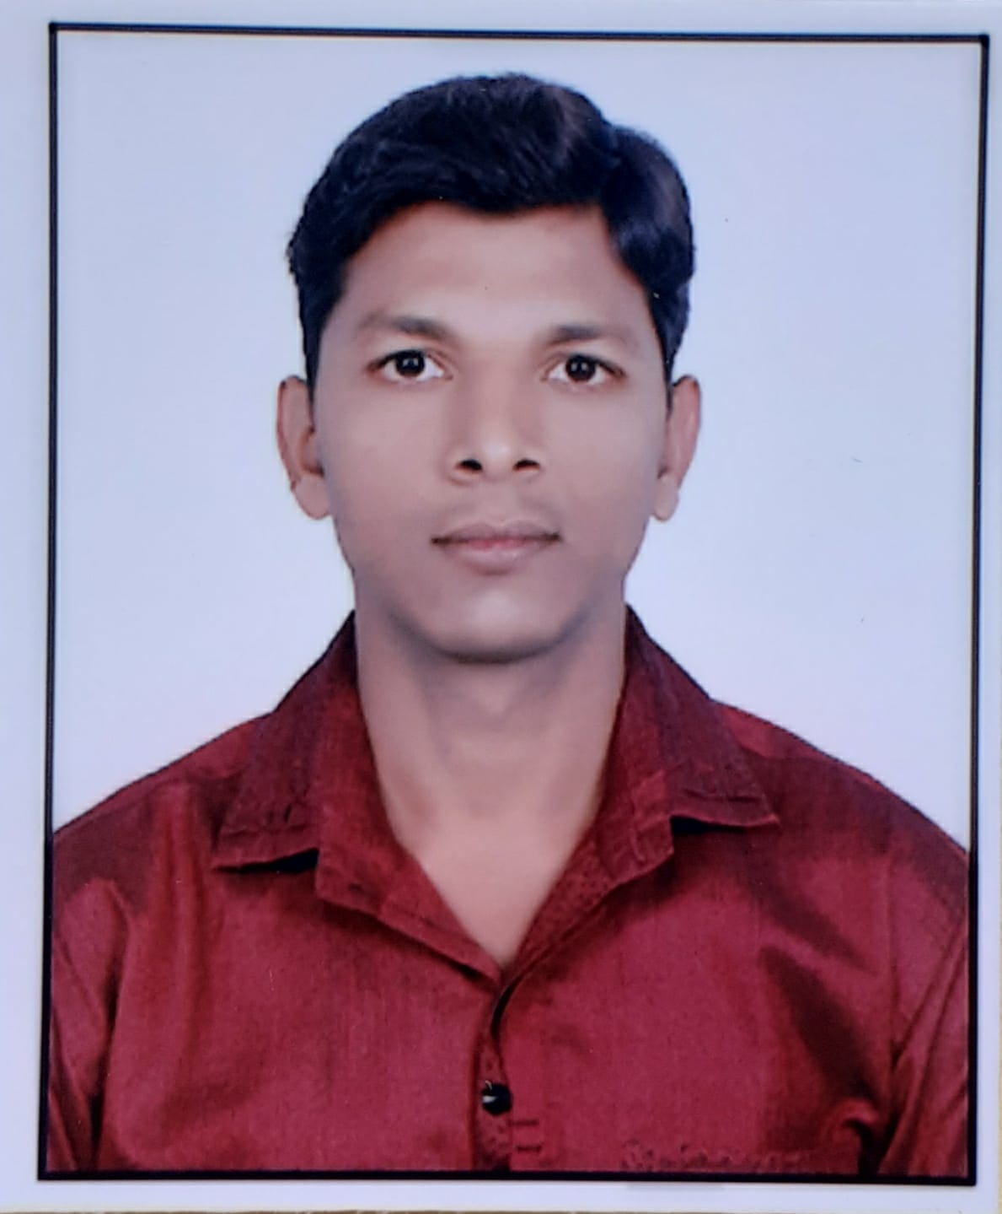
VIKAS KULSHRESTHA
Mobile: 9529192599, E-Mail: vikaskulshrestha88@gmail.com

BREIF OVERVIEW

- An effective communicator with excellent relationship building & interpersonal skills. Strong analytical, problem solving & organizational abilities.
- I want to work for a professional skill development organisation to achieve heights in lieu to my current skill base. I am keen to learn and want to work in a competitive working environment.
PROFICIENCY FORTE

- Good Relationship management Skills.
- Good people and coordination skills.

Work experience

Currently working with Rama Eye and general hospital as front office executive
Manage the front desk and Its operations
Attend incoming and outgoing calls and transfer Calls to Various departments.
Keep a record of daily visitors and help in coordination of ID and other visitor cards.
Manage distribution of documents, If any, received from visitors.
To take care of any other tasks as and when given related to managing the front office

ACADEMIA

- 2009-2011 Post Graduation From EIILM University, Sikkim
- 2005-2008 Graduation from University of Rajasthan, Jaipur
- 2002-2004 Intermediate from RBSE, Ajmer
- 2001-2002 Matriculation from RBSE, Ajmer

COMPUTER SKILLS

- MS Office, MS Word, MS Excel,
- Win.98,/2007/XP and internet proficiency.

PERSONAL DOSSIER

Full Name: Vikas Kulshrestha
Date of Birth: 17th April 1988
Address: 115, Padmavati Colony A, Kings Road, Nirman Nagar, Jaipur, PIN- 302019.
Marital Status: Single
Languages known: English, Hindi, Rajasthani

Place:- Jaipur
Date:-

